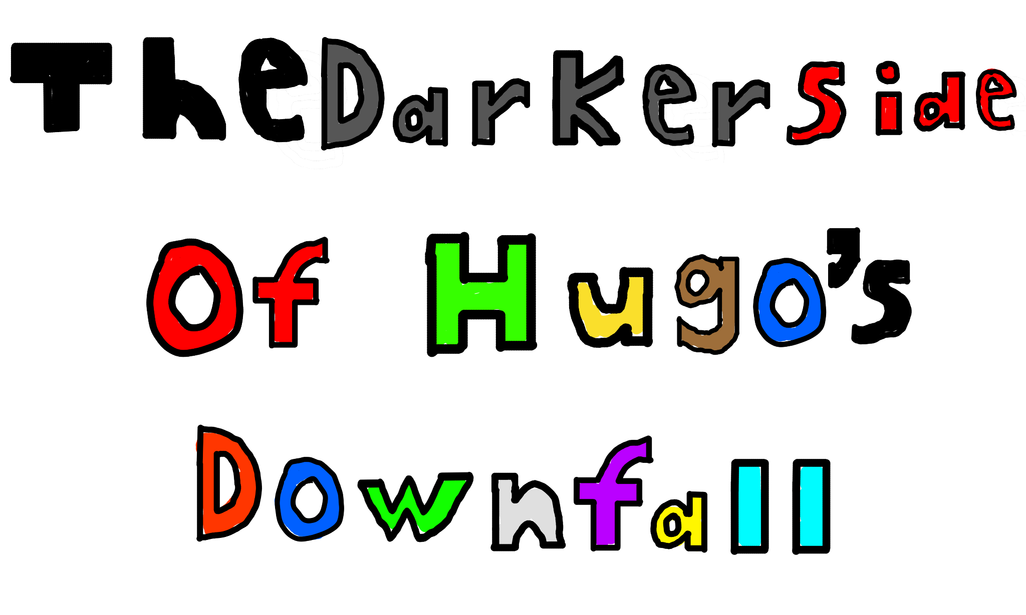

See You Online Games has recently released a new game called Hugo’s Uprising, and its sequel Hugo’s Downfall. One would think that the sequel would have the same or increased rating than the initial game. However, Hugo’s Uprising was given an E 10+ because of some semi-intense content, and Hugo’s Downfall, the sequel, was given an E for everyone rating. When asked about this rating adjustment, the studio seemed to acknowledge the theory but refused to speak on it after.

Now who is See You Online Studios? They have made great games like Gears of Steam, Science Of War, and the trilogy A Flame’s Spirit. These are all great games, and they were created with very specific audiences in mind. So in terms of rating for their games they have been all over the place. I have experienced a funny response from people complaining about there being mature content in a game rated M for mature. It is almost like a rating means something.

Because they are all over the place, I believe there is a darker version of Hugo’s Downfall. The company admitted that if they get 30 million people to get to VIP member status, it has a 2 percent chance they might confirm if this is real or not. To become a VIP member, one must pay 5 dollars. In reality, we have no idea what the upside is here. Some people do not believe that there is a darker version of Hugo’s Downfall. So let me prove it to you. All proof points to the fact that a darker version can exist. I am about to spoil the game for you, so I will give you an opportunity to click off now if you don’t want to be spoiled.

So let’s dive in. First off, one of the biggest draws of the marketing was that there were more crossovers than the first game. Because the first game was marketed as a huge crossover game. Secondly, a new character was introduced called Skelagon. Hugo actually made him an extremely long time ago. Hugo trapped him and now reawakened him. Skelagon was a humanoid skeleton dragon hybrid creature like the one depicted below.

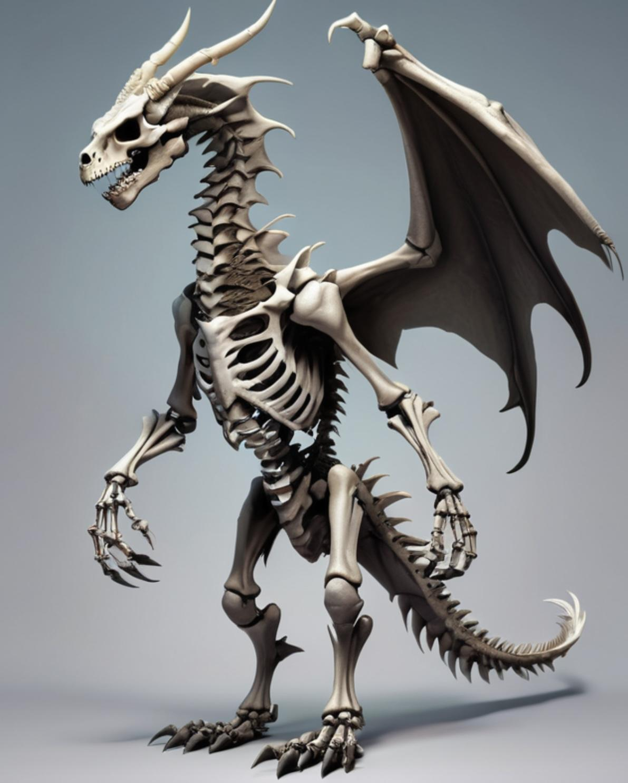

Image was taken by the company CEO Lucas Wold

Skelagon was introduced at the end of Hugo’s Uprising as a terrifying character and functioned as a teaser for the sequel. Due to his violent nature, Skelagon only appears in cutscenes. He doesn’t exist in the gameplay because that would be too intense for an E for everyone game. There is even a chase sequence with him where he is chasing you, but it gets cut short, and it isn’t really a chase. Sounds to me he would be too scary for younger audiences.

There is also a plot thread where Skelagon infects Hugo with something that makes Hugo act really out of character at certain points. For example, there is a scene where Hugo is holding a different villain by the neck.

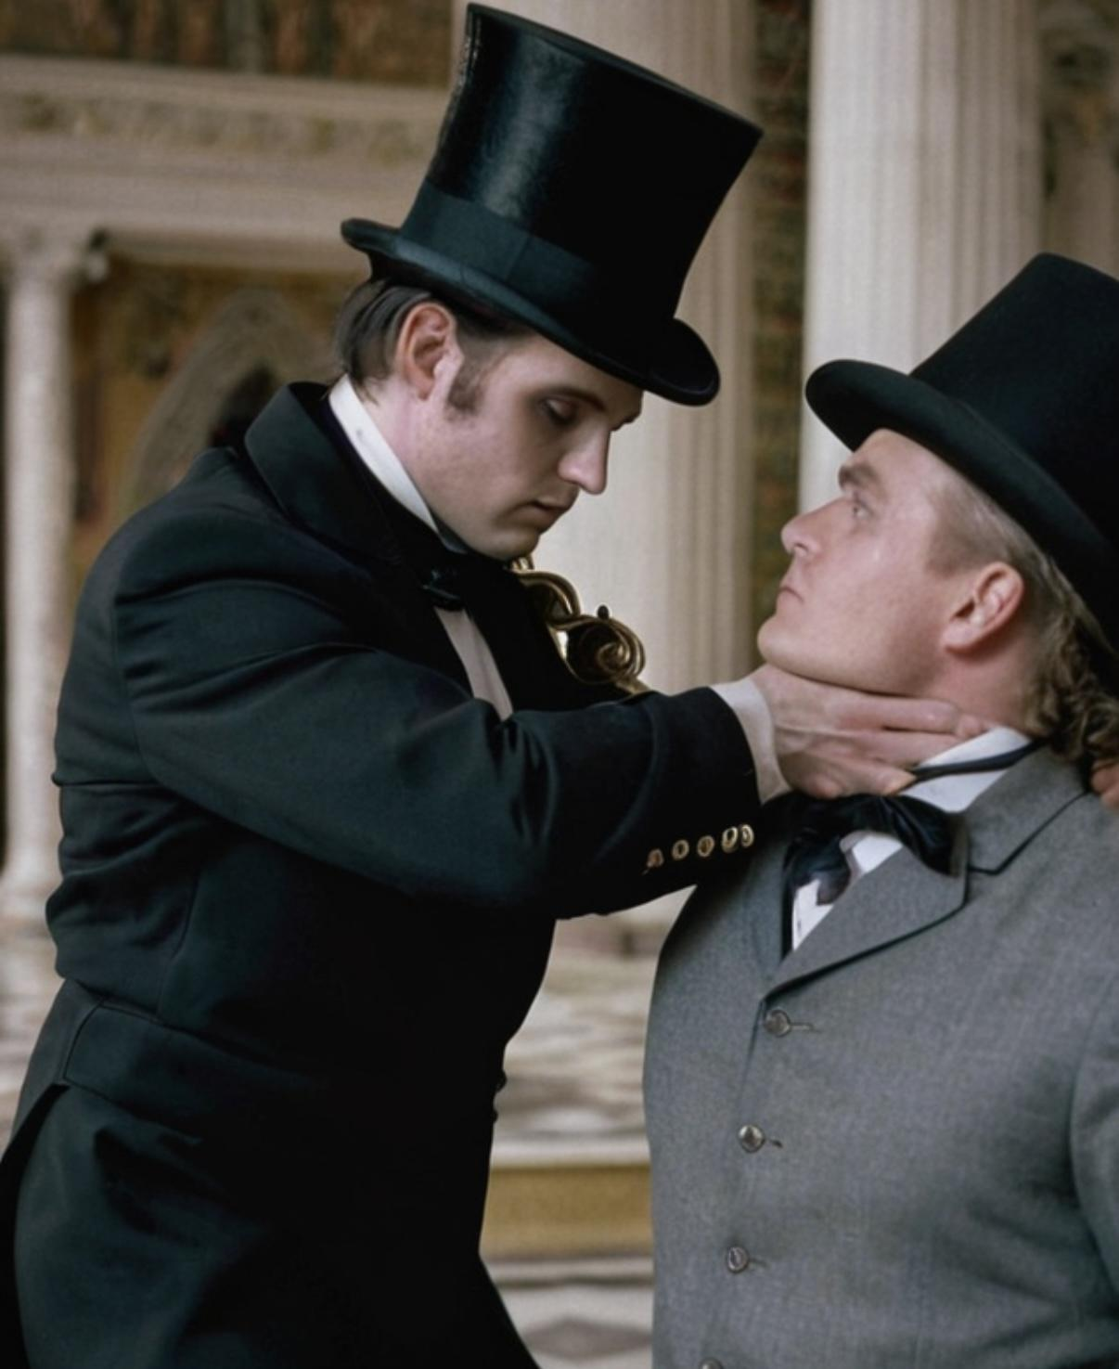

Image was taken by the company CEO Lucas Wold

This part Hugo grabs the other villain. Then Hugo flys them both really high in the air and Hugo gets out his sword. Then he doesn’t use his sword and instead drops the other villain. This implies the dedication of the creator to ensure that this game is censored enough to maintain an E for everyone rating.

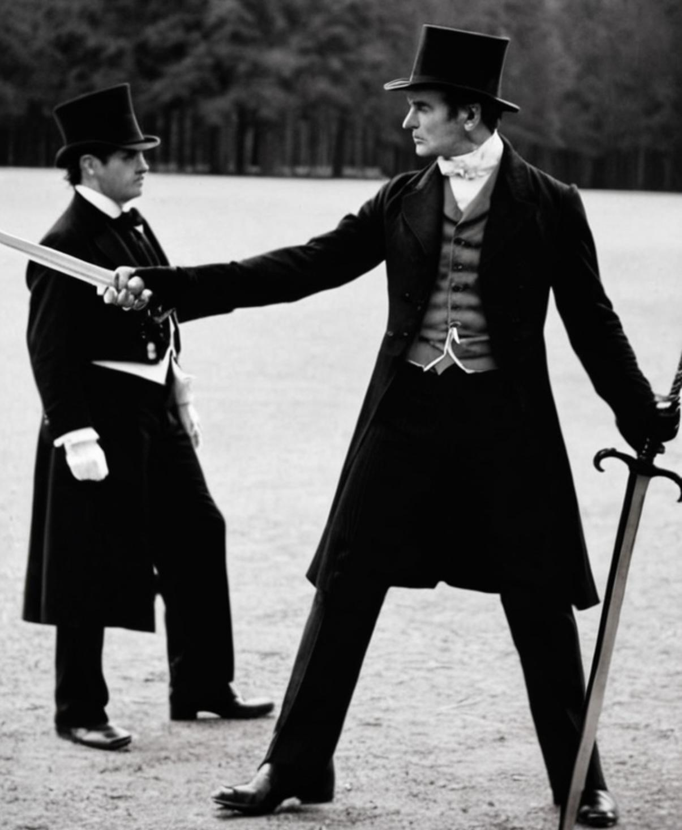

Image was taken by the company CEO Lucas Wold

This scene goes black and white because it is transitioning to fully black and you hear a scream. Afterwards the other villain Hugo does this too as an arm cast. They cut the scene where you actually see him stab him so this probably was another case of censorship.

It also implies the ability to create a darker version, perhaps for those with VIP status. But this is yet to be seen, and is just my theory at this point. These are just three big examples of the existence of a darker version, but there are many more hints in the game that I don’t have time to get into in this article. You can probably find them yourself. Because the studio refuses to speak on this we need to get the 30 million to get VIP status. It has very low chance of actually being successful but it is currently the best option we have